Interface Message Queue Manager
Interface messages that cannot be automatically processed by the athenaNet MX engine may be routed into one of several message statuses. In particular, clients are required to manually resolve conditions that cause an interface message to be routed into either ERROR or CBOERROR (generic error and billing-related error, respectively) status. It is important to note that messages in ERROR and CBOERROR status have not yet been processed.

Objective

After reading this training guide you will be able to complete the following:

- Confirm that all users have the necessary permissions to manage the Interface Message Queue Manager (IMQM).
- Locate the Interface Message Queue Manager in athenaNet.
- Understand how the “simple search” and “advanced search” filters work.
- Understand the most common errors which you might find in the IMQM.
- Learn how to correct errors and create interface maps via the error queue.
- Learn how to create maps manually and proactively, before messages ERROR in the queue.
- Learn how to utilize the batch mapping functionality.
- Learn how to read an interface message.

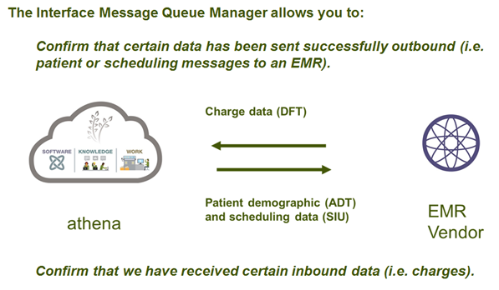
Permissions
You first want to make sure that you have the correct user permissions.
Permission | Use Case
Interface Admin: View Message Queue | You want to be able to view the IMQM.
Interface Admin: Map Insurance Messages | You need to map insurance messages.
Interface Admin: Map Messages (except Insurances) | You need to map all messages excluding insurance messages (e.g. provider and department mappings).
Interface Admin: File Upload Interface | You want to be able to upload files via the interface.

If you do not have the correct permissions, please call the Client Service Center.

How do I find the Interface Message Queue Manager?
There are two ways to get to the IMQM…
- HomeWorkflow Dashboard (scroll to the bottom of the page).
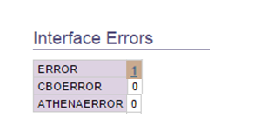
Click the error hyper link and it will drill you right into the error queue.

Or

2. AdminPractice Manager AdminInterface Message Queue Manager

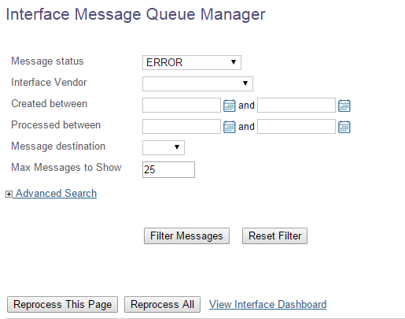

What do these filters mean?

Basic Search

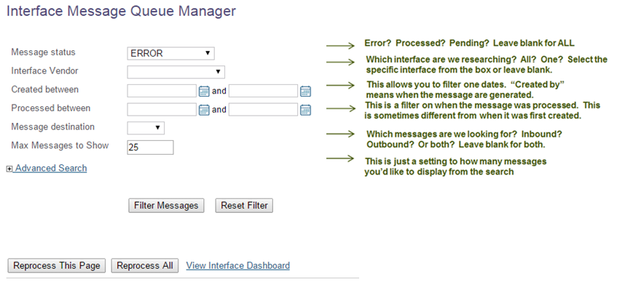

Advanced Search
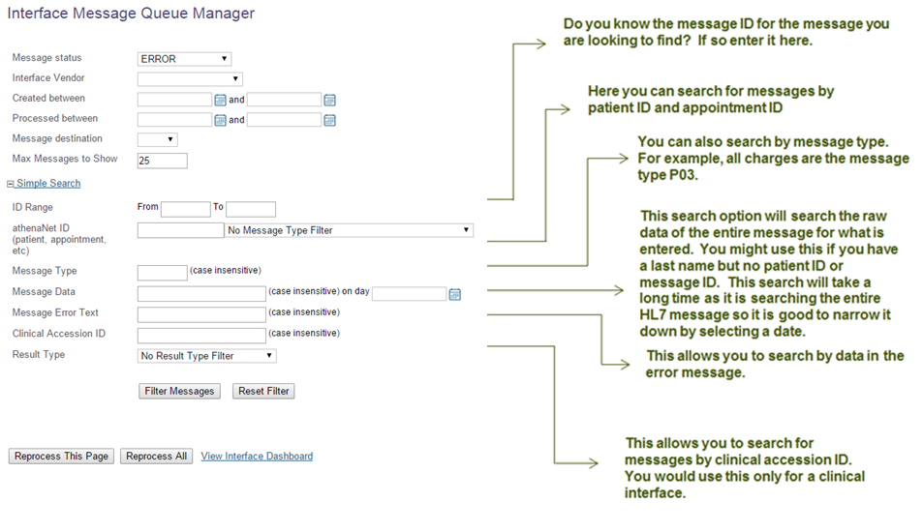

What are some common errors?
These message statuses generally indicate one of the following conditions:
- invalid/missing patient ID/first name/last name/other demographic information
- unmapped/missing provider
- unmapped/missing department of service
- unmapped/missing relation-to-insured
- invalid/missing diagnosis codes
- invalid/missing procedure codes/modifiers
- invalid/missing date of service

Below are some examples of common errors messages you might see:
Missing procedure codes:
The user can click the “fix link” to add the code and then REPROCESS the message

Missing Diagnosis codes:
The user can click the “fix link” to add the code and then REPROCESS the message

Provider must be mapped:
Often the other system will have different provider IDs, these IDs need to be mapped to the athena IDs. Click the “fix” link to map the provider. Then you must reprocess the message after the map has been created. This is the same for other data elements such as departments.

Fee Schedule Issues:
Often you will get these errors when the CPT codes sent over in a charge message do not match the fee schedule in athena. The fee schedule will either need to be modified to reflect this or the charge will need to be modified with appropriate CPT codes and resent from the sending system

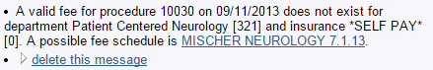

Appointment ID Issues:
This message is saying that the appointment ID given in the charge message was cancelled.

Insurance Packages:
Insurance package IDs from foreign systems must be mapped to the athena insurance package IDs.

Creating Interface Mappings via the Error Queue
The most common task will be to “map” data elements contained in interface messages via an interface mapping – to link the remote vendor system ID values to athenaNet ID values. For example, athenaNet may store relationship to insured “Other” as ID 10, whereas a remote vendor system may store the same relationship to insured as ID 5482 – the athenaNet MX engine must be instructed that 5482 is in fact equal to 10, for the relationship to insured map key.
When accessing the Add Interface Mapping screen through a “must be mapped” type link, the data values will be pre-filled, where data is available (contrast this with manually creating an interface mapping as described below, where the data values will not be pre-filled). Once the map is created and saved, you will not need to map this data element again.
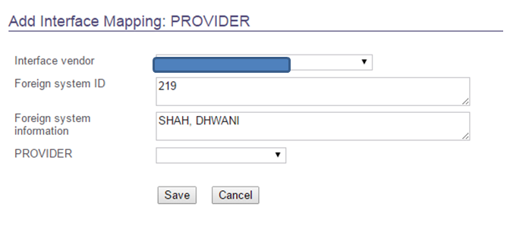

Creating Interface Mappings Manually (Proactively versus Reactively)
Interface mappings can also be viewed and manually created (following a “must be mapped” link is not required). Under the same Practice Manager Admin menu where we found the Interface Message Queue Manager link, choose “Interface Mappings”. The below screen will be displayed (by default, no interface mappings are displayed until display criteria are selected).
To view existing interface mappings, in the “Filter Interface Maps” portion of the screen, choose a map key (e.g. provider, department, relationship to insured) and an interface vendor, and choose the Filter button. The existing interface mappings matching those criteria will then display on the screen.
To manually create an interface mapping, choose a map key in the “Add New Map” portion of the screen, and choose the Add New button. The same add dialogue shown when mapping data through the Interface Message Queue “fix link” will be displayed again, but without any data values pre-filled this time.
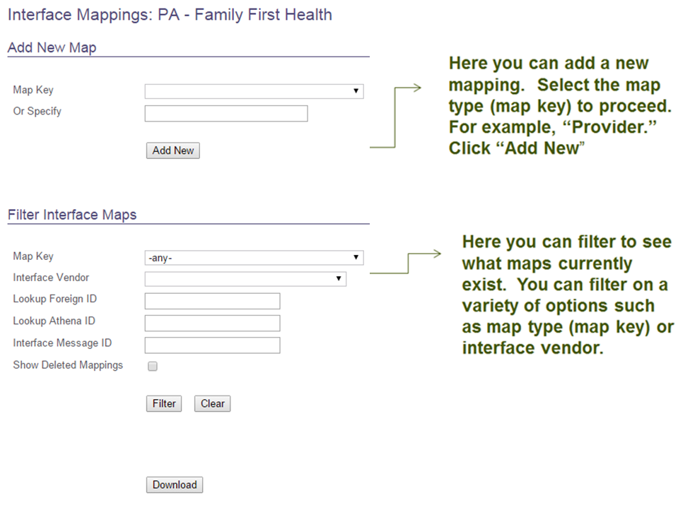

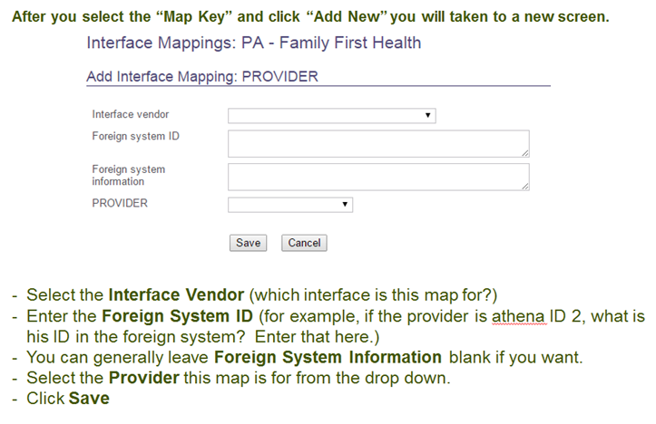
Batch Mappings
The Batch Mappings administration screen displays lists of messages, grouped by error text. The default view shows up to 100 error reasons in ERROR status, sorted by the highest count first. This can be a convenient tool when facing a high volume of ERROR messages, especially if the same mapping needs repeat often.

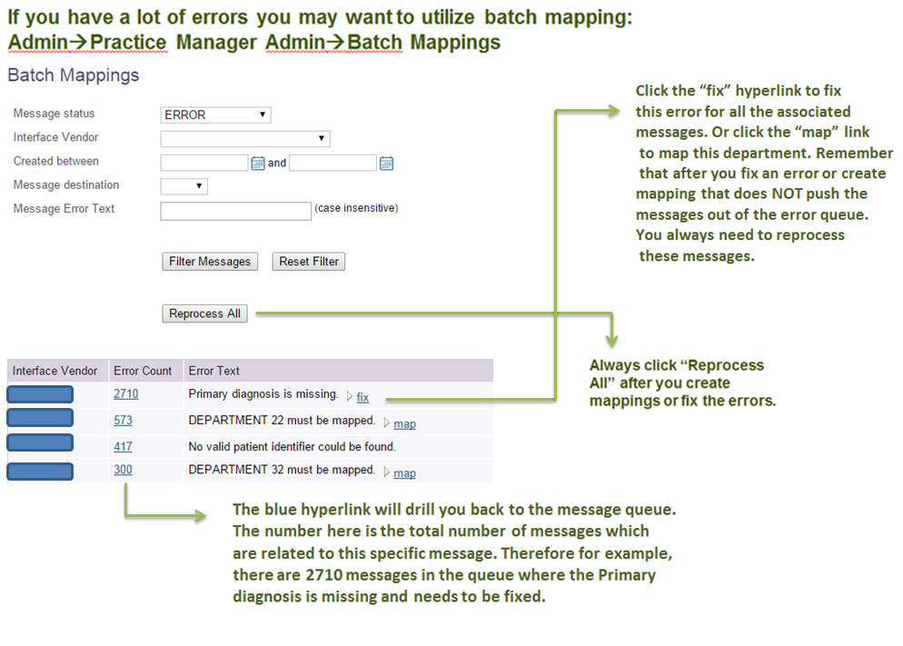
Reading an Error Message
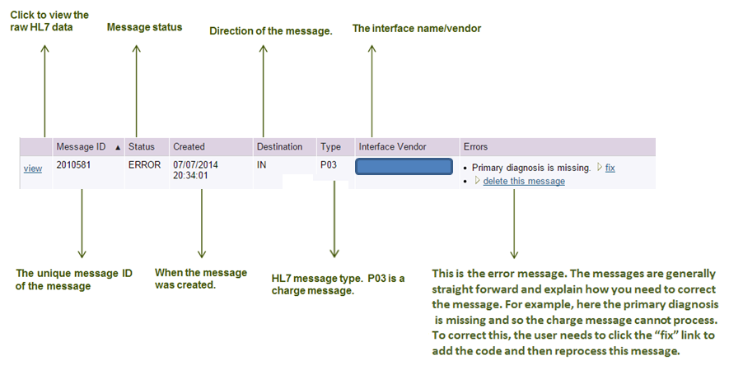
Notes on Insurance Mappings
- The customer will have three options for handling unmapped insurance package errors in the ERROR queue:
- Customer may identify an existing athenaNet insurance package representing the same insurance.
- Customer may request a new insurance package through standard athenaNet workflow; this will be subject to the standard athenaNet insurance-approval turnaround time. Upon approval of the requested package, the client will be able to map the insurance normally and process the message. Until this time, however, the message will remain in ERROR status and will not be processed.
- Customer has the option of mapping the insurance to GENERIC OTHER COMMERCIAL. Any claim with insurance GENERIC OTHER COMMERCIAL will drop immediately to paper if the insurance name and address have been provided; otherwise, the claim will be put into HOLD status. The paper claim will be constructed according to the athenaNet default format; specifically it will be billed under the client’s tax ID, with no payer-specific provider or group numbers or other payer-specific formatting. If, after 75 days, no payment has been received on this claim, athenaNet will automatically transfer the charges to self-pay; athenahealth will perform no follow-up prior to transferring the charges to self-pay. In addition, athenahealth reserves the right to charge a $20 processing fee per mail return for claims mapped to GENERIC OTHER COMMERCIAL.

Things to Remember…
- Always keep an eye on the interface errors. These are easily viewable when in the Workflow Dashboard.
- Any message in error is a message that will not process unless corrected.
- After you create a mapping or fix an error, ALWAYS REPROCESS the message.

